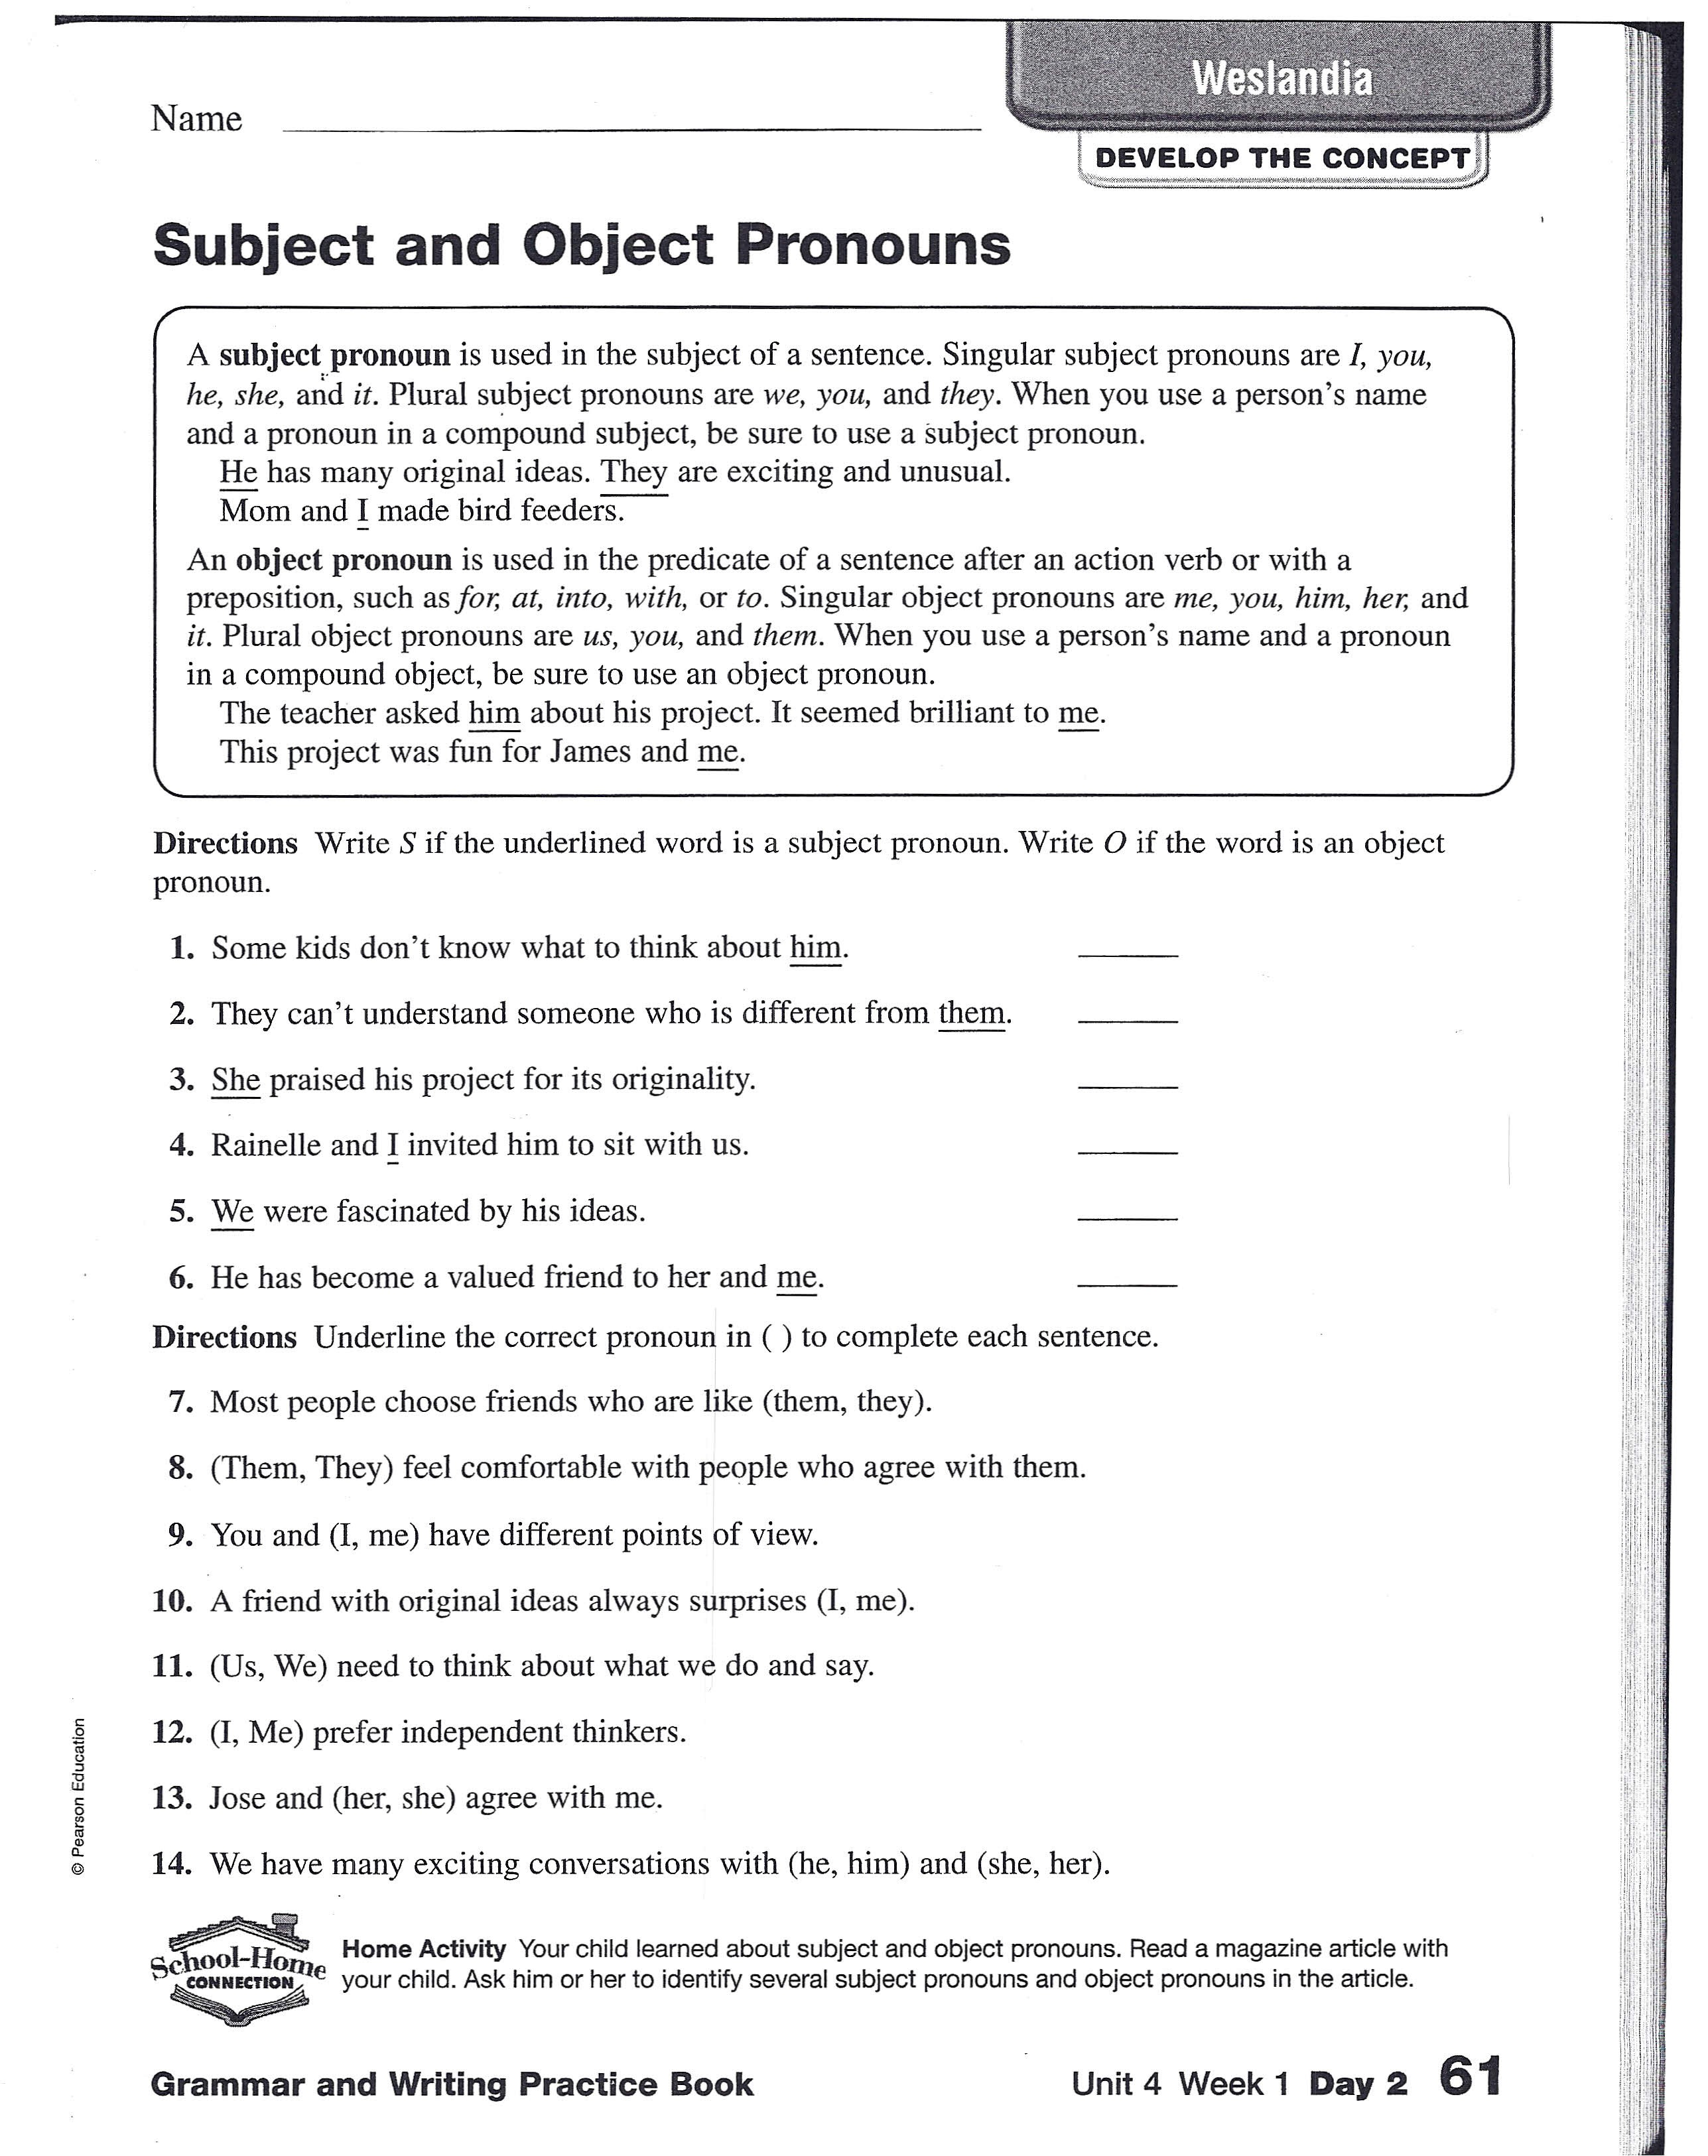

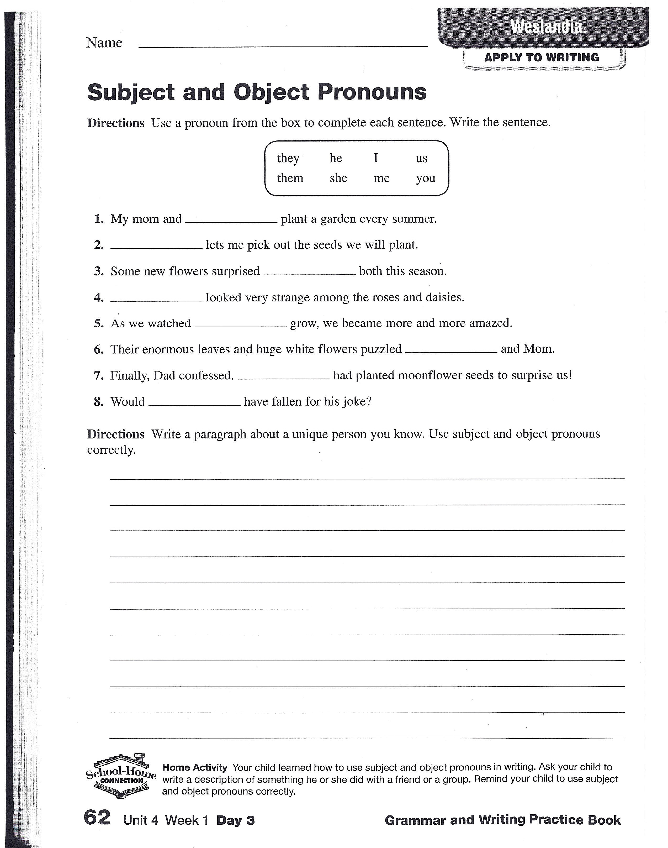

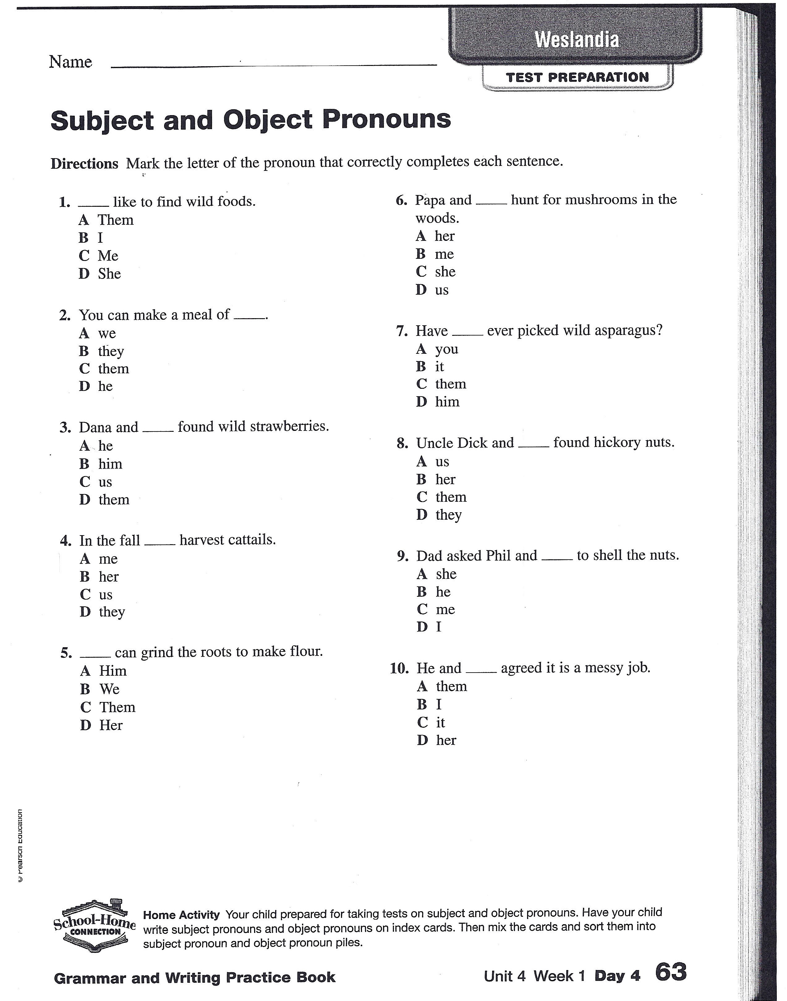

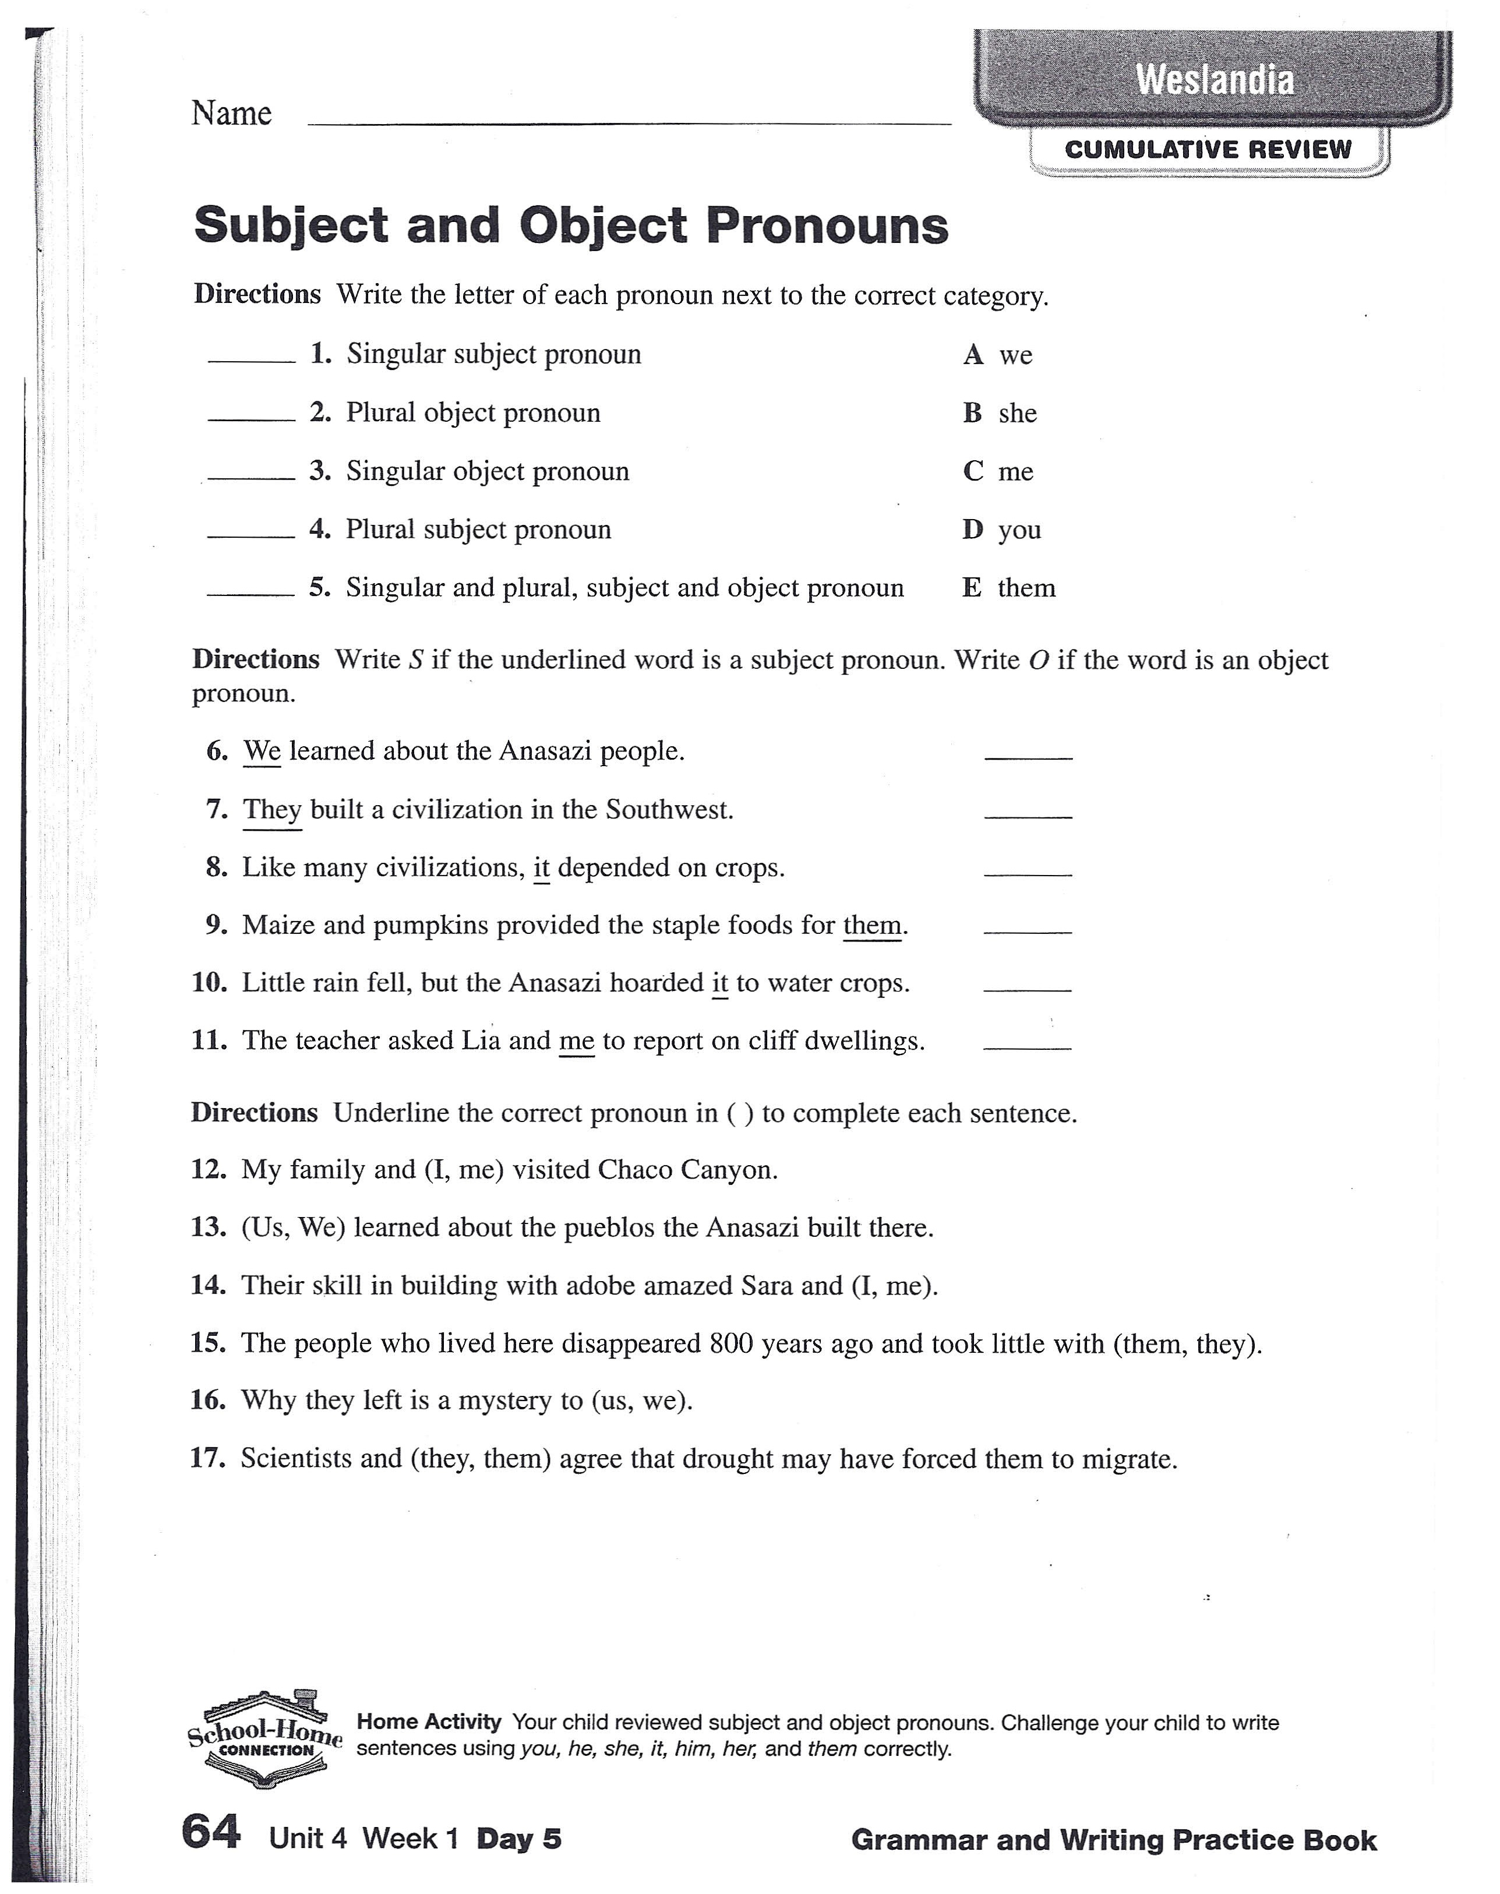

# [www.perfect-english-grammar.com](http://www.perfect-english-grammar.com/)

Modals of Ability Exercise 1

Put in ‘can’ / ‘can’t’ / ‘could’ / ‘couldn’t’. If none is possible, use ‘be able to’ in the correct tense:

1. you swim when you were 10?
2. We get to the meeting on time yesterday because the train was delayed by one hour.
3. He arrive at the party on time, even after missing the train, so he was very pleased.
4. He’s amazing, he speak 5 languages including Chinese.
5. I drive a car until I was 34, then I moved to the countryside so I had to learn.
6. I looked everywhere for my glasses but I find them anywhere.
7. I searched for your house for ages, luckily I find it in the end.
8. She’s 7 years old but she read yet – her parents are getting her extra lessons.
9. I read the book three times but I understand it.
10. James speak Japanese when he lived in Japan, but he’s forgotten most of it now.
11. I understand the chapter we had to read for homework. It was so difficult.
12. I lift this box – it’s too heavy! Would you help me?
13. Lucy make it to our meeting after all. She’s stuck in traffic at the moment.
14. John play tennis really well. He’s champion of his club.
15. Unfortunately, I really sing at all! No-one in my family is musical either.
16. When the car broke down I was really pleased because I

solve the problem.

1. Julian play excellent golf when he was only ten.
2. My grandmother use a computer until last month. Since then, she’s been taking lessons at the library.
3. I open this window. I think it’s stuck!
4. Gill play the piano. She’s never studied it.

Answers:

1. **Could** you swim when you were 10?
2. We **couldn’t** get to the meeting on time yesterday because the train was delayed by one hour.
3. He **was able to** arrive at the party on time, even after missing the train, so he was very pleased.
4. He’s amazing, he **can** speak 5 languages including Chinese.
5. I **couldn’t** drive a car until I was 34, then I moved to the countryside so I had to learn.
6. I looked everywhere for my glasses but I **couldn’t** find them anywhere.
7. I searched for your house for ages, luckily I **was able to** find it in the end.
8. She’s 7 years old but she **can’t** read yet – her parents are getting her extra lessons.
9. I read the book three times but I **couldn’t** understand it.
10. James **could** speak Japanese when he lived in Japan, but he’s forgotten most of it now.
11. I **couldn’t** understand the chapter we had to read for homework. It was so difficult.
12. I **can’t** lift this box – it’s too heavy! Would you help me?
13. Lucy **can’t** make it to our meeting after all. She’s stuck in traffic at the moment.
14. John **can** play tennis really well. He’s champion of his club.
15. Unfortunately, I really **can’t** sing at all! No-one in my family is musical either.
16. When the car broke down I was really pleased because I **was able to** solve the problem.
17. Julian **could** play excellent golf when he was only ten.
18. My grandmother **couldn’t** use a computer until last month. Since then, she’s been taking lessons at the library.
19. I **can’t** open this window. I think it’s stuck!
20. Gill **can’t** play the piano. She’s never studied it.

## Fill in the correct form of one of the phrasal verbs from the box.

fall for figure out give in

go along with look for

pull through put on

run into show up take off

talk down to

**fall for figure out give in**

**go along with look for pay for**

**pull through put on run into show up take off**

**talk down to**

1. I looked for my keys everywhere but I couldn’t

where I put them

1. I you at the party but I couldn’t see you.
2. Although he tried to eat less he some weight during the holidays
3. I Karen and her new boyfriend when I went shopping
4. Over a hundred people for the news conference
5. Our plane an hour late because of the fog.
6. My son drove me crazy about buying a new bike, so finally I

.

1. Erich is very sick at the moment but I am sure he’ll
2. She shouldn’t him like that. You’re not his boss.
3. I understand you opinion but I have to Linda on this question.
4. John told me that he didn’t steal but I didn’t his lies.
5. Can I the drinks with a credit card?

## Fill in the correct form of one of the phrasal verbs from the box.

**call in cheat on**

**get around to hand back look at**

**look up pick out point out point to run over set up take apart**

1. Can you the man carrying the gun?
2. Hank has been his wife for years.
3. The police chief couldn’t solve the case , so he wanted to

the FBI

1. The guard my ID card to me.
2. I her and told her that I loved her.
3. She a meeting with Jimmy and his lawyer.
4. Don’t worry about the broken window. I’ll it one of these days.
5. I the words that our teacher dictated.
6. The general showed me a satellite photo and I the enemy tanks.
7. When I saw Melanie I to her and gave her a hug
8. The clock is completely broken. I’ll try to it

and fix it.

1. Have you a dress to wear at the party?

## Fill in the correct form of one of the phrasal verbs from the box.

* 1. I looked for my keys everywhere but I couldn’t ***figure out*** where I put them
  2. I ***looked for*** you at the party but I couldn’t see you.
  3. Although he tried to eat less he ***put on*** some weight during the holidays
  4. I ***ran into*** Karen and her new boyfriend when I went shopping
  5. Over a hundred people ***showed up*** for the news conference
  6. Our plane ***took off*** an hour late because of the fog.
  7. My son drove me crazy about buying a new bike, so finally I ***gave in***.
  8. Erich is very sick at the moment but I am sure he’ll ***pull through***
  9. She shouldn’t ***talk down to*** him like that. You’re not his boss.
  10. I understand you opinion but I have to ***go along with*** Linda on this question.
  11. John told me that he didn’t steal but I didn’t ***fall for*** his lies.
  12. Can I ***pay for*** the drinks with a credit card?

## Fill in the correct form of one of the phrasal verbs from the box.

1. Can you ***point to*** the man carrying the gun?
2. Hank has been ***cheating on*** his wife for years.
3. The police chief couldn’t solve the case , so he wanted to ***call in*** the FBI
4. The guard ***handed*** my ID card ***back*** to me.
5. I ***looked at*** her and told her tht I loved her.
6. She ***set up*** a meeting with Jimmy and his lawyer.
7. Don’t worry about the broken window. I’ll ***get around to*** it one of these days.
8. I ***looked up*** the words that our teacher dictated.
9. The general showed me a satellite photo and I ***pointed out*** the enemy tanks.
10. When I saw Melanie I ***ran over*** to her and gave her a hug
11. The clock is completely broken. I’ll try to ***take*** it ***apart*** and fix it.
12. Have you ***picked out*** a dress to wear at the party?